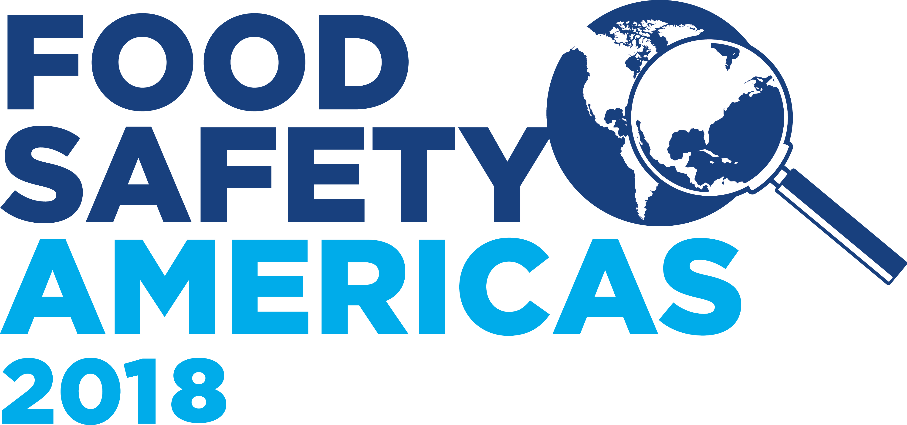 |  | BRC Food Safety (Americas) Awards 2018  Entry Form
Nomination Category: |  | BRC Certification Body of the Year
 |  | BRC Auditor of the Year – Individual
Approved Training Partner and consultant of the year –
Individual or Training Center
 |  | BRC Certificated Site of the Year *This is applicable to Food Safety, Packaging, Retail, Storage & Distribution, Consumer Products & Agents & Brokers
Nominee Information
Name:
Job Title:
Employer:
Address
City/State/ZIP:
Phone:
Email:
Nominator Information
Name:
Job Title:
Employer:
Address
City/State/ZIP:
Phone:
Email:
Professional relationship to Nominee:
Is the Nominee aware of this nomination?
How would you prefer to be contacted? | Email  Phone

Attachment
All nominations must include the required evidence outlined in the Criteria document

Submission
Please email this application form with any evidence as outlined in the Criteria document to sarah.brown@brcglobalstandards.com by February 28th 2018.

